Name: Shaunak Deshpande

IC C

Roll number: 04

GR Number: 11911180

Lab-6

**Linux commands**

**Ls**



**Mkdir**

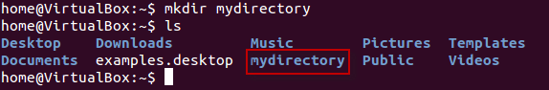

**Rmdir**

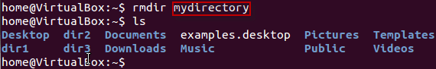

**mv (for renaming)**

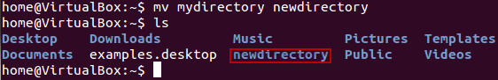

**Man**

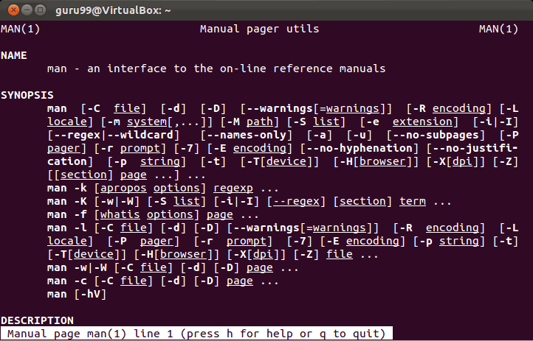

**History**

